Caso de uso
Podemos ejecutar el script de ScriptableCart de SuiteScript para agregar un tax amount que queremos (el water tax), a la sales order resultante, cuando se agrega un item al cart identificado trigger.
Un item es trigger cuando es water taxable y el customer es taxable.

Activar Scriptable Cart
- An administrator must enable the following features: Advanced Site Customization, and Client SuiteScript:
  - Setup > Company > Enable Features.
  - On the Enable Features page:
    - Select the Web Presence tab and check the Advanced Site Customization box to enable the feature.
    - Select the SuiteCloud tab and check the Client SuiteScript box to enable the feature.
After you have turned on the required features:
- go to Commerce > Websites > Website List (Administrator) and click Edit next to your website name. Click setup tab:
  - Check the Scriptable Cart and Checkout box

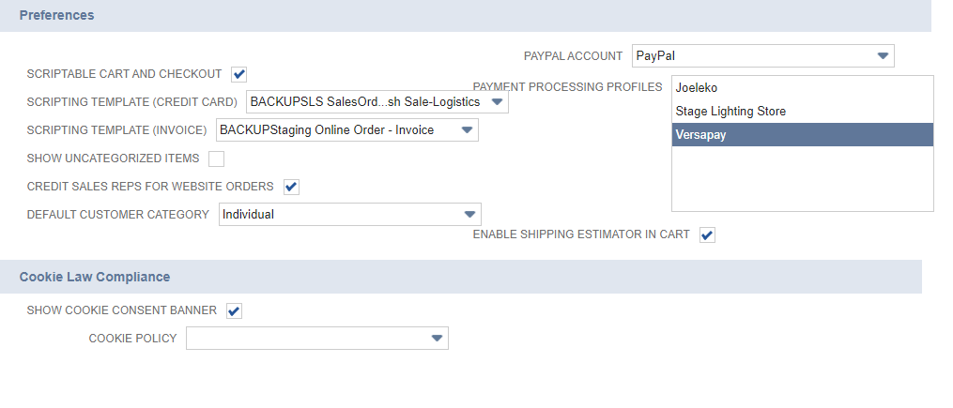

Create a new client script
Creo una carpeta de nombre ScriptableCart o lo que quiera, luego dentro de ella creo un archivo addTaxAmountScriptableCart.CS.js, y le agrego:
function debug (message) {
nlapiLogExecution('DEBUG', 'Example Scriptable Cart', message);
}

function customRecalc () {
debug('recalc called!');
}

function customValidateLine (type) {
if (type = 'item') {
var itemId = nlapiGetCurrentLineItemValue('item', 'item');
debug('Line validated: ' + itemId);
}
return true;
}

Función a usar: recalc
Uso recalc ya que es un evento que ocurre una vez que se cambia el shopping cart:
When a shopper adds an item to the shopping cart, the ‘recalc' event is triggered, and the order amount is recalculated (commit).

Ir a Customization -> Scripting -> Scripts, creo uno nuevo y agrego el file desde mi computadora.
Agrego el file de AddWaterTaxAmountScriptableCart.CS.js.
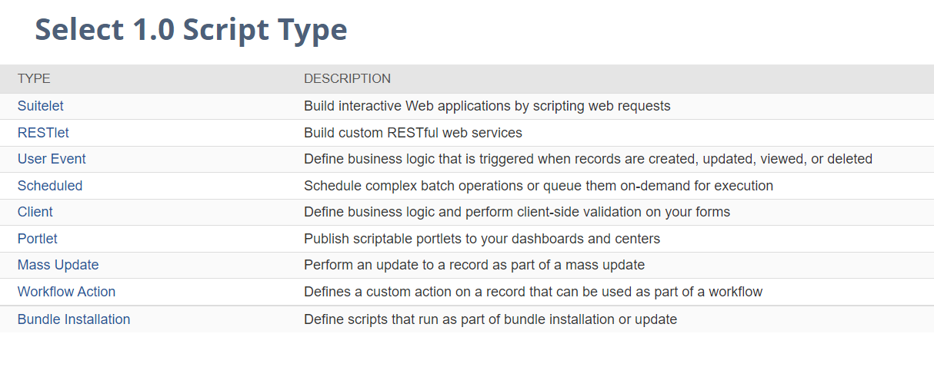
Elijo Client.

Luego, On the Script page, enter or set the following:
- Name: Example Scriptable Cart
- ID: _example_scriptable_cart
- Scripts tab: (tener en cuenta que acá agrego el module antes, porque en el archivo lo definí así):
  - In the Recalc Function field: AddWaterTaxModule.recalc
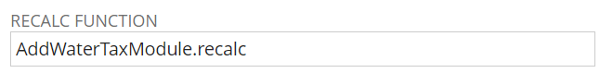
  - In the Field Changed Function field: AddWaterTaxModule.fieldChanged
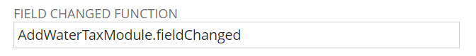
- Deployment tab
  - Applies To: Sales Order
  - Status: Released
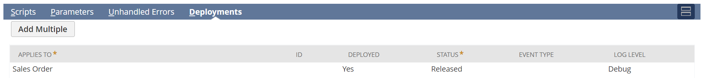

Todos los roles,
Web store, web application y Other.

Aprieto Save & Deploy.

Script deployment
Seteo en Audience: todos los roles.
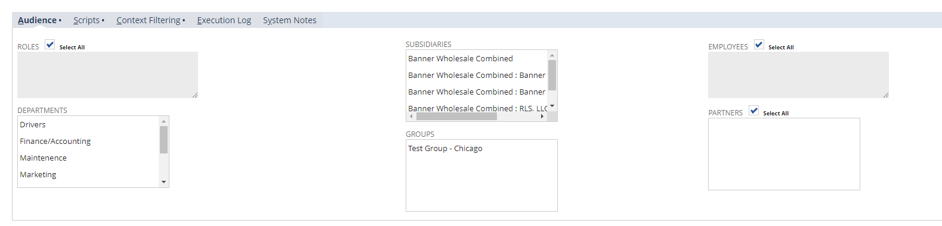
Seteo en Context filtering: Web Application y Web Store.
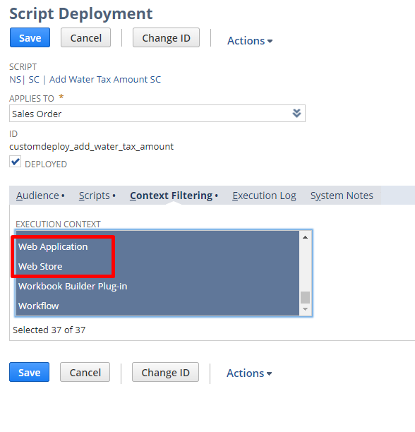

On the Audience subtab of the script deployment record, make sure that Customer Center is selected. (1)

Testing
- Go to your Commerce website and either add an item to the cart or change the quantity of an item already in the cart. Remember, the recalc function is called when the contents of the cart change therefore these changes should invoke your script.
- Cada vez que modifique el script en backend, agregarle el parámetro a la web store ckinvalidate=T.
- To check the script execution log for the message generated by your script, go to: Customization > Scripting > Scripts.
- Find your script, Example Scriptable Cart, in the list and click View.
- In the Execution Log tab, check for the Debug message from the script: recalc called!

Notas
Tenemos que obtener los siguientes valores:
- Customer Field: Water Tax Exempt?
- Si el producto es water taxable custitem_nscs_tax_code
- water tax amount

No podemos hacer un nlapiLoadRecord porque scriptable cart corre con roles de customer center y de shopper, no de admin, entonces hay que hacer un truco para poder correrlo, y es agregar a la sales order el campo del item.

Entonces lo que vamos a hacer es agregar a cada línea de la sales order, es decir la línea de item, el campo nuevo, esto se puede hacer mediante agregar un transaction line field:

Transaction line field is one per line item.

- Water Tax Exempt:
Creo un transaction line field para el campo de Water Tax Exempt? (custentity_nscs_water_tax_exempt) y lo vamos a agregar a la sales order.
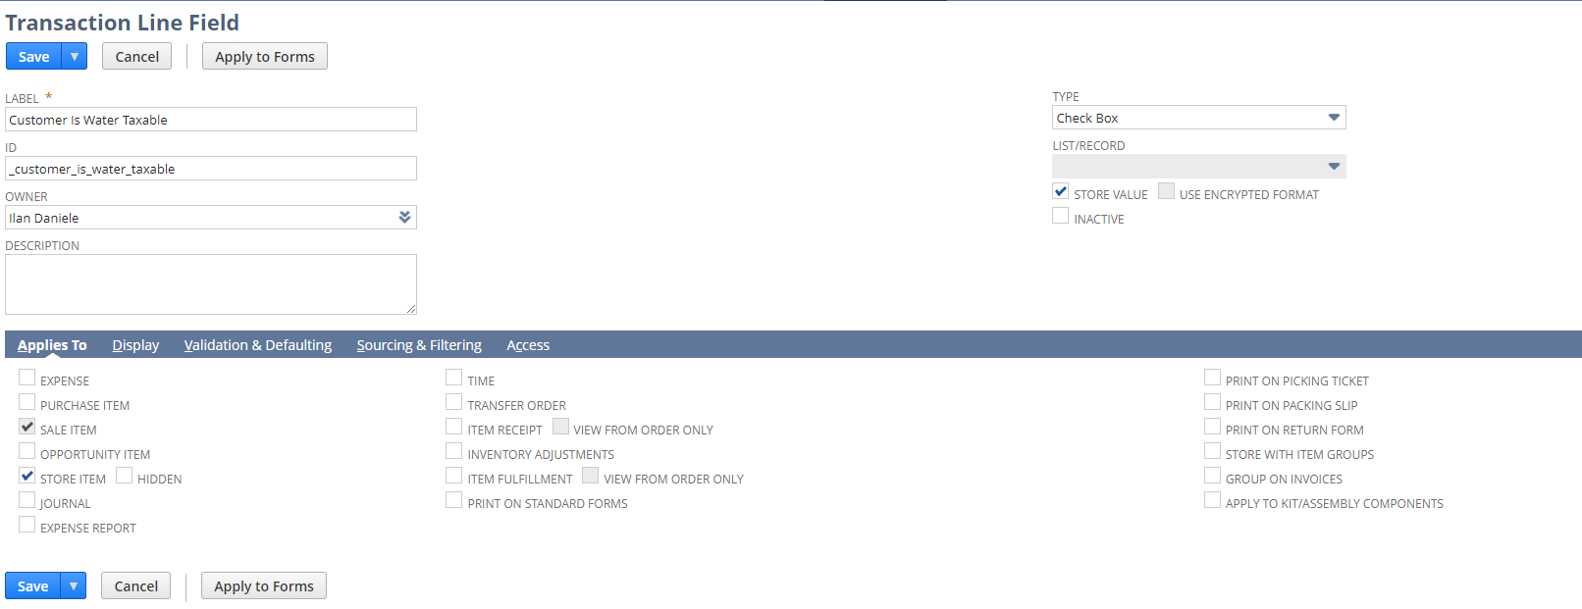
Solo para SALE ITEM y STORE ITEM, y el tipo es checkbox, el mismo que viene del customer record.
Luego, en la vista de “Sourcing and filtering” selecciono customer para que muestre la opción de water tax exempt?
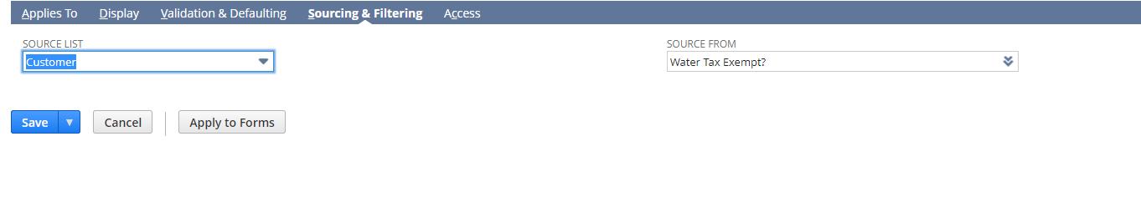
Y se crea un campo con nombre custcol_customer_is_water_taxable al que le puedo hacer get en mi Client Script de Scriptable Cart.

- Tax Code:
Creo un transaction line field para el campo de Tax Code (custitem_nscs_tax_code):
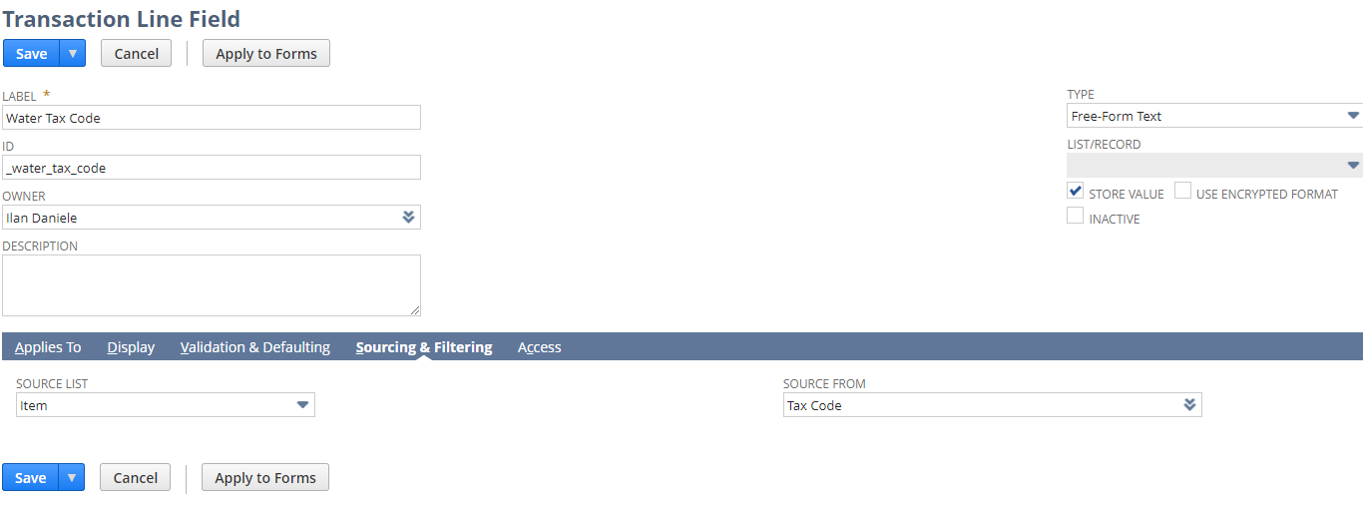

Y se crea un campo con nombre custcol_water_tax_code al que le puedo hacer get en mi Client Script de Scriptable Cart.

- Water Tax Amount: lo mismo

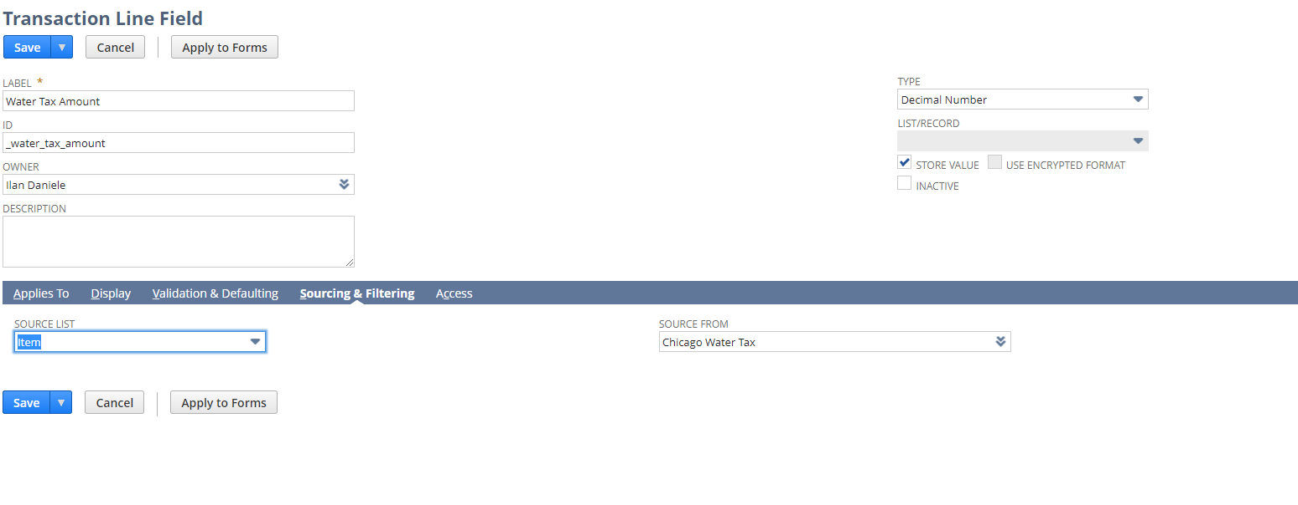

Preguntar:
Que campo puedo usar?
Sales order
- handlingtax1rate:
  - Type-> text
  - Description: This field shows that tax rate for the handling tax code selected.
- handlingtaxcode:
  - Type -> select
  - Description: Select the tax code that should apply to any handling charges on this order.
- istaxable:
  - Type -> checkbox
  - Description: Place a check mark in this box if this order is taxable.
- taxitem:
  - Type -> select
  - Description: A tax item is a tax that you collect at one certain rate and pay to one tax agency for this invoice. NetSuite inserts the tax item for this customer from the record at Lists > Customers. To change it just for this sale, select another tax item. To add additional choices to this list, go to Lists > New Item > Sales Tax Item.
- taxrate:
  - Type -> float
  - Description: NetSuite inserts the percentage rate of the tax item from its record at Lists > Items. You can change it here for just this transaction if you wish.
- taxtotal:
  - Type -> currency
  - Description: NetSuite multiplies the tax rate by the taxable total of line items and enters it here.

- total:
  - Type -> currency
  - Description: NetSuite computes the total of line items, tax and shipping costs, and then enters it here.
- Totalcostestimate:
  - Type -> currency
  - Description: Estimated Cost: Estimated cost of the specific number of items; estimated rate x quantity = estimated cost.
Sublists:

Item:
- Rate:
  - rate
  - Unit price
- Taxcode:
  - Select
  - Tax Code
- Taxrate1:
  - Percent
  - Tax rate

Taxdetails:
- Taxamount:
  - Currency
- Netamount: currency
- Taxbasis: currency
- Taxcode: select
- Taxrate: percent

Agregar un item a las sales order uqe sea water tax y listo.

